MTX Alarm/Warning Parsing 5-4-2022 Update

Objective:

Take the current manual process of collecting matrix jam data with a USB and analyzing in Excel into an automated process to collect, store and analyze jam stat data.

Status:

|  |  |
| --- | --- |
| Action Item | Date |
| Create function that automatically loads the data from the .csv file into the Oracle database | 5-12 |
| Get python able to talk to Oracle SQL | 5-12 |
| Duplicate the function the pulls alarm data to also pull warning data | 5-12 |
| Create UI that allows data from Oracle SQL database to be plotted/examined  -----stacked bar graph of 10 most frequent error codes across all handlers  --stacked bar graph of 10 longest duration error codes across all handlers | 5-19 |
| Ability to drill down into data and or more advanced analysis features (will have to have conversation about what this ideally looks like/what is relevant) | 6-16 |
| Aesthetic changes to UI,  Productize software | 6-23 |

-created repository in Oracle SQL database

-created a script to remotely extract alarm data from handlers

-manually loaded all alarm data from the last 4 weeks into database

-added constraint on database to prevent duplicate records

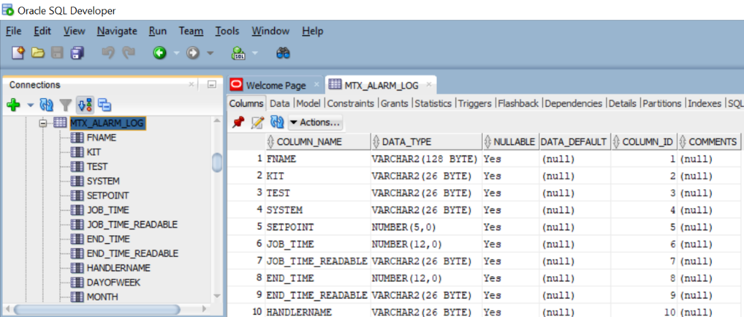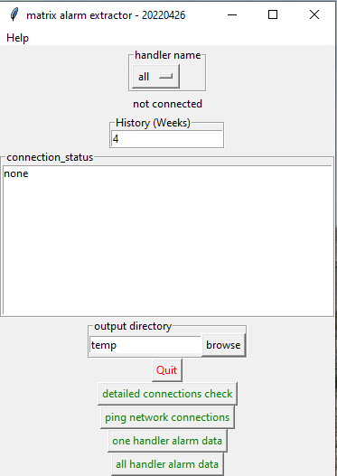

Figure & 2: Initial User Interface (left) Oracle SQL Database showing repository (right)

Issues:

Fixing development environment, being able to talk to Oracle SQL through Python

Recommendations:

Continue project as planned.

Additional detail of project status:

Currently what exists is a Python program written by Lauderdale that is able to pull alarm data off of handlers and put the information into a .csv fil. At the moment you are able to choose how far back in time you want to pull data from in a time period of weeks, and you are also able to specify if you data want all handlers or just one specifically. The data is output into a .csv file. Additionally the database exists that sorts the data pulled off of the handlers, at the moment the .csv file needs to be manually loaded into the database, in the future, the program will be able to complete this step. The database is at the moment able to filter out duplicate alarms